Exclusive 30-Hour Short Term Course in Front-end Web Engineering
Course Overview:
Participants in this comprehensive 30-hour course will delve into key aspects of Front-end Web Engineering, covering essential technologies including CSS3, Java, Web API, and Forms. Mr. Zahin Omar Alwa's wealth of experience will provide invaluable insights into the practical applications of these technologies, ensuring participants gain hands-on experience in creating dynamic and responsive web interfaces.
Course Highlights:
- In-depth coverage of CSS3 for advanced styling and layout techniques.
- Practical insights into Java for interactive and dynamic web applications.
- Understanding and implementation of Web API for seamless integration of web services.
- Mastery of Forms for efficient data collection and user interaction.
Registration Information:
Registration Fee: Rs. 1000/- only
About Mr. Zahin Omar Alwa:
Mr. Zahin Omar Alwa brings over 10 years of experience in driving innovation across AdTech, MarTech, Fintech, EduTech, and Travel Domains. As the Head of Technology at IION and Engineering Director and Leader, his expertise will provide participants with real-world insights and practical knowledge.
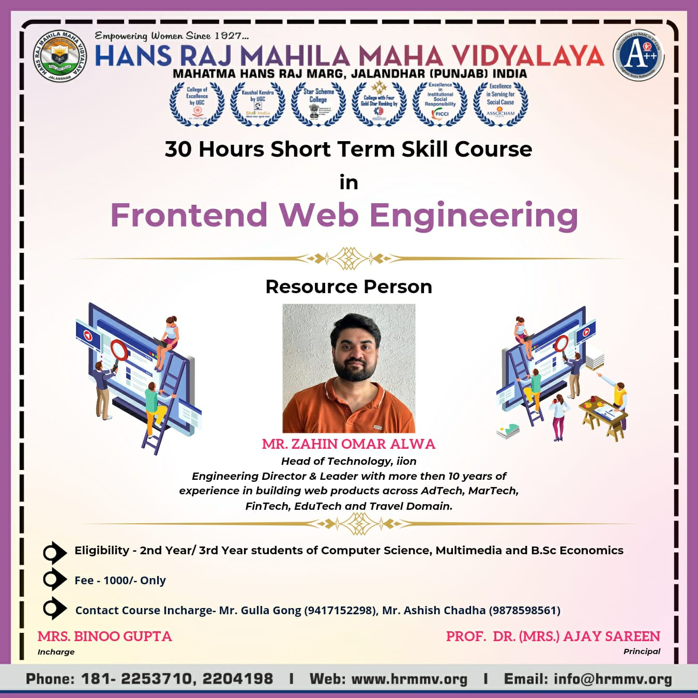
Course Curriculum by Mr. Zahin Omar Alwa
- HTML5
Elements & Semantics
Images
Forms & validations
Building Web pages
- CSS3
Fundamentals (Inheritance & Cascade, Specificity.
Selectors, Box Model, Colors)
Fonts (Web fonts, CSS Icons, Google Fonts)
Layouts (Flow, Positioning, Floats, Flexbox, Grids)
Transitions. Transforms & Animation
- JavaScript & DOM
Fundaments (Syntax, Variables/Assignment, Values,
Operators, Functions, Objects)
Regular Expressions (Pattern Matching, Searching
Strings)
DOM Manipulation
Fetch API & Ajax (XHR)
- Web API
Battery API, Media API (Video and Audio), User
Interaction API
Drag and Drop API, Navigation API
History API, Canvas 2D API, FullScreen API
Web Storage API (Cookies, Local Storage and
Session Storage), Geolocation API
- React JS
Components (Class vs Functional), Basics (JSX,
Props vs State, Conditional Rendering)
Rendering (Component Life Cycle, Lists and Keys,
Render Props, Refs, Events)
Forms (React Hook Form. Formik)
Hooks (Writing Custom Hooks, Common Hooks)

Photographs of Conducting Course
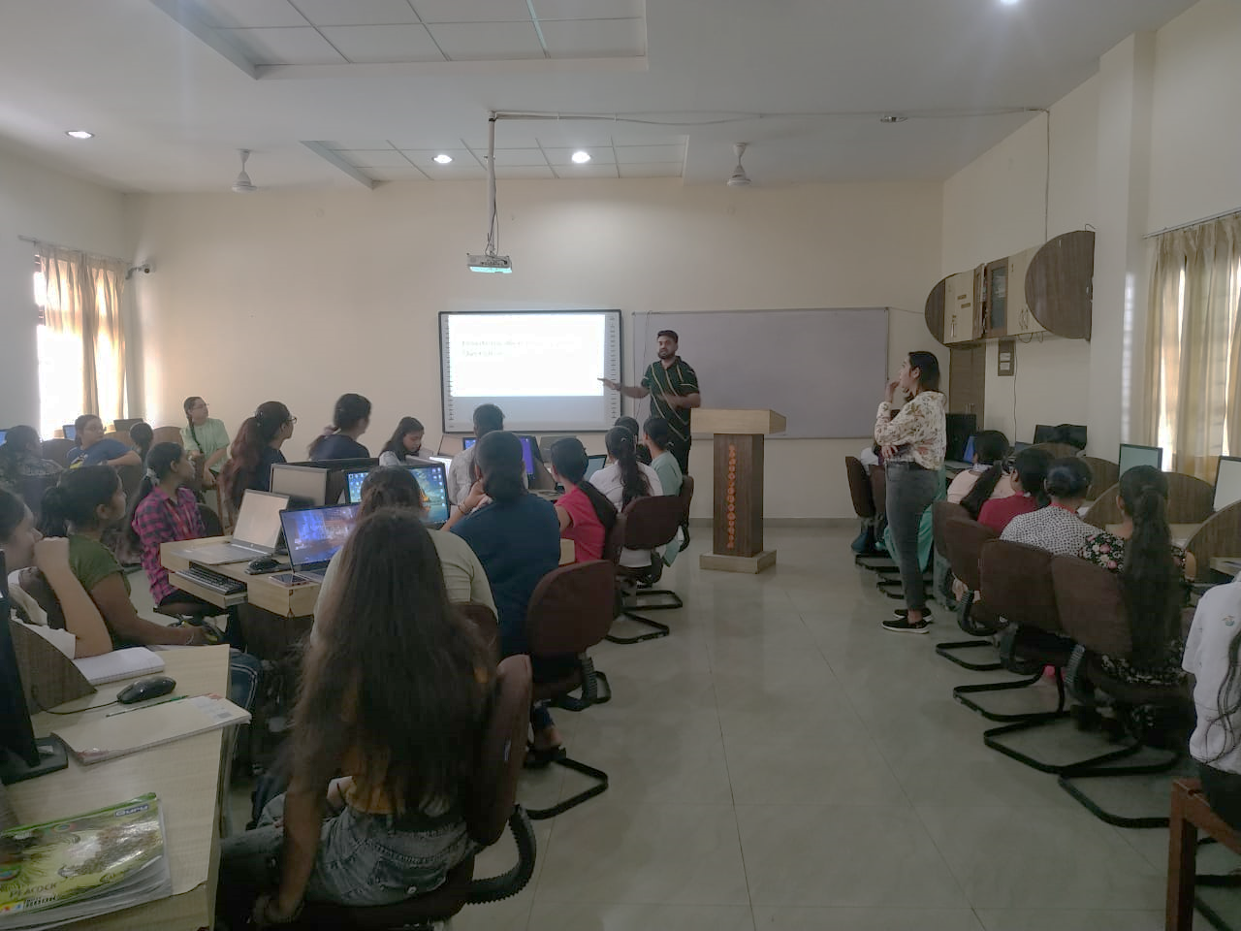
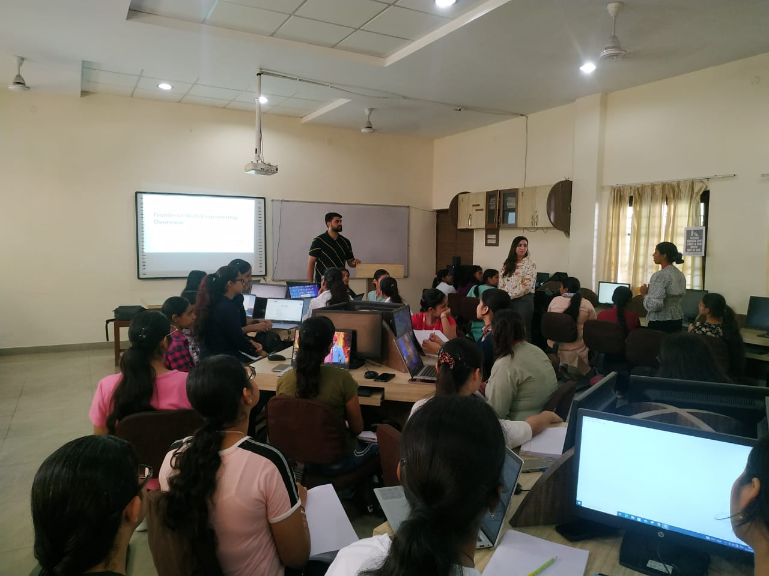
list of students enrolled
S.No | Name | Father'sName | Class | Roll no. | Phone no. | Fee receipt no
1 | Parneet Kaur | Anoop Singh | BSc(Eco) sem-5 | 12219 | 6284269095 | 50155
2 | Shradha | Gulshan Sabharwal | BSc(CS) Sem-5 | 22112 | 9814486688 | 50155
3 | Anjali Devi | Shanker Tiwari | BSc(CS) Sem-5 | 22114 | 8283004976 | 50155
4 | Nanourin | Najam Akhtar | BSc(CS) Sem-5 | 22120 | 7901933890 | 50155
5 | Vridhi Kundra | Ritesh kundra | BCA Sem-5 | 40112 | 9780250051 | 50155
6 | Bhavna Choudhary | Vinod kumar | BCA Sem-5 | 40115 | 7973627030 | 50155
7 | Nikita Bali | Vinod bali | BCA Sem-5 | 40120 | 7814174363 | 50155
8 | Anushika | Mukesh kumar | BCA Sem-5 | 40122 | 9876583578 | 50155
9 | Yuvika Seth | Rohit seth | BCA Sem-5 | 40123 | 7658015125 | 50155
10 | Jasleen | Amarjit singh | BCA Sem-5 | 40139 | 9417829422 | 50155
11 | Banisha | Sudesh kumar | BCA Sem-5 | 40150 | 8837651358 | 50155
12 | Isha Arora | Raj kumar | BCA Sem-5 | 40151 | 8283843398 | 50155
13 | Avneet Kaur | Ramandeep singh | BCA Sem-5 | 40157 | 9877707408 | 50155
14 | Tanisha | Rajesh kalia | BCA Sem-5 | 40159 | 7814174506 | 50155
15 | Taranpreet Kaur | Sardul singh | BCA Sem-5 | 40164 | 8968763911 | 50155
16 | Asseya Batool | Ghulam ali | BCA Sem-5 | 40174 | 9149491405 | 50561
17 | Kashish | Jaspal singh | BCA-Sem-3 | 40201 | 9872648488 | 50155
18 | Sunaina | Gaya prasad | BCA-Sem-3 | 40206 | 8559048574 | 50155
19 | Ravneet | Sukhdev Singh | BCA-Sem-3 | 40218 | 9872561335 | 50155
20 | Davinder | Ranjit Singh | BCA-Sem-3 | 40220 | 9056392583 | 50155
21 | Saneha | Varinder Singh | BCA-Sem-3 | 40225 | 8558980240 | 50155
22 | Mridul | Neeraj Kumar | BCA-Sem-3 | 40233 | 9781638489 | 50155
23 | Navneet | Hardeep Kumar | BCA-Sem-3 | 40243 | 8264984114 | 50155
24 | Ranjeeta | Kuldeep Kumar | BCA-Sem-3 | 40244 | 7814818959 | 50155
25 | Kanchan | Jaspal | BCA-Sem-3 | 40246 | 7696120535 | 50155
26 | Megha | Jatinder Arora | BCA-Sem-3 | 40249 | 8725090372 | 50155
27 | Bhavya | Rakesh Kumar | BCA-Sem-3 | 40250 | 6284674325 | 50155
28 | Jasleen | Gurmeet Singh | BCA Sem-3 | 40252 | 8360265530 | 50561
29 | Manreet Kaur | Paramjit Singh | BCA Sem-3 | 40260 | 8898235000 | 50155
30 | Sushma | Jay Ram Prasad | BCA-Sem-3 | 40264 | 9646868839 | 50155
31 | Shivani | Shiv Kumar | BCA Sem-3 | 40268 | 8528648593 | 50327
32 | Neha | Sanjay Singh | BCA-Sem-3 | 40270 | 9877088316 | 50327
33 | Preeti | Dyashankar Kumar Prasad | BCA-Sem-3 | 40279 | 9523970506 | 50327
34 | Anu | Vinod Mishra | BCA-Sem-3 | 40280 | 9263454144 | 50327
35 | Vaishnavi | Shankar Mishra | BCA-Sem-3 | 40295 | 7296029506 | 50327
36 | Archana | Ram Kumar | BCA-Sem-3 | 40296 | 9304851883 | 50327
37 | Drishti | Purnwasi Chaudhary | BCA-Sem-3 | 40297 | 9523742131 | 50327
38 | Sakshi | Manoj Kumar Bhagat | BCA-Sem-3 | 40298 | 7364897019 | 50327
39 | Nidhi | Vinod Kumar | BSc(IT) Sem-5 | 41101 | 6280541813 | 50327
40 | Gurveen Kaur | Jagdev Singh | BSc(IT) Sem-5 | 41103 | 6284255380 | 50327
41 | Akashdeep Kaur | Sukhbir Singh | BSc(IT) Sem-5 | 41106 | 7696957163 | 50327
42 | Nidhi | Jhannan | BSc(IT) Sem-5 | 41111 | 7009583036 | 50327
43 | Mehak | Narsingh Yadav | BSc(IT) Sem-5 | 41112 | 8968641040 | 50327
44 | Manpreet Kaur | Harwinder Singh | BSc(IT) Sem-5 | 41116 | 8283952622 | 50327
45 | Komal | Rakesh Kumar | BSc(IT) Sem-5 | 41118 | 9876828212 | 50327
46 | Meenakshi Devi | Mansa Ram | BSc(IT) Sem-5 | 41120 | 6006439168 | 50327
47 | Tanvi | Kailash Kumar Aggarwal | M.Voc Web Tech Sem 3 | 55110 | 7009896585 | 50304
48 | Shreya | Manoj Aggarwal | M.Voc Web Tech Sem 3 | 55116 | 9872348385 | 50305
49 | Palvi | Balwinder kumar | BCA Sem-3 | 40217 | 7681940270 | N/A

Fee Receipts of 30-Hour Short Term Course in Front-end Web Engineering
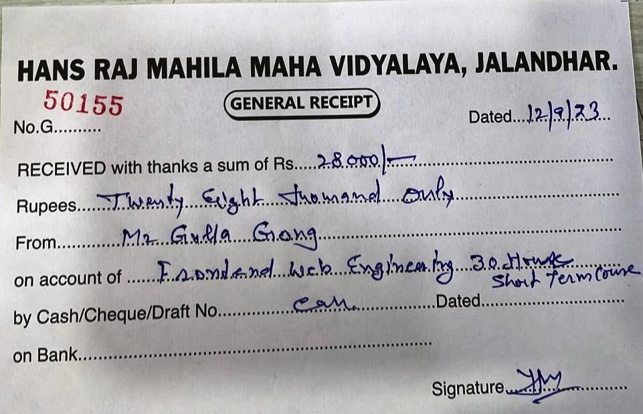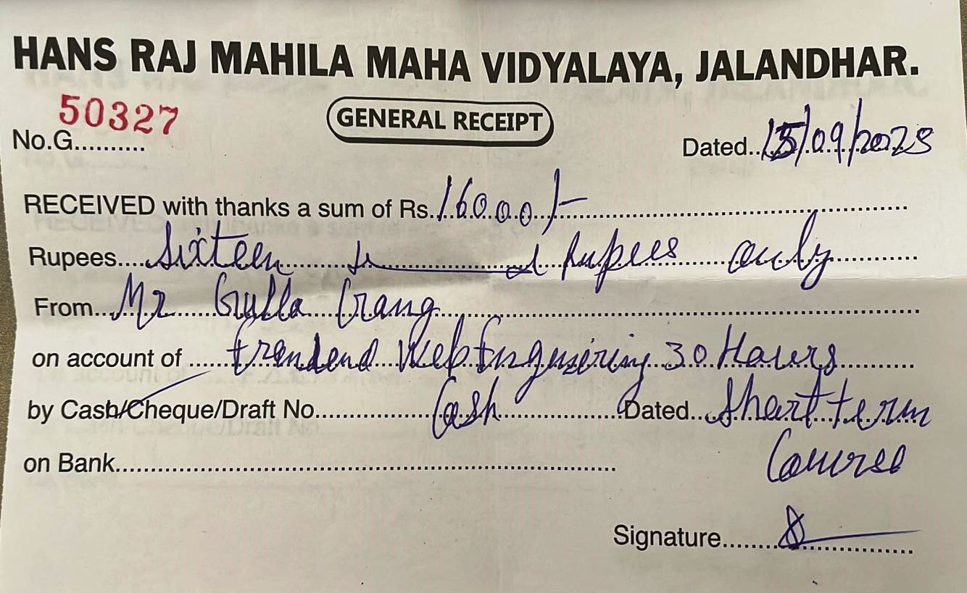
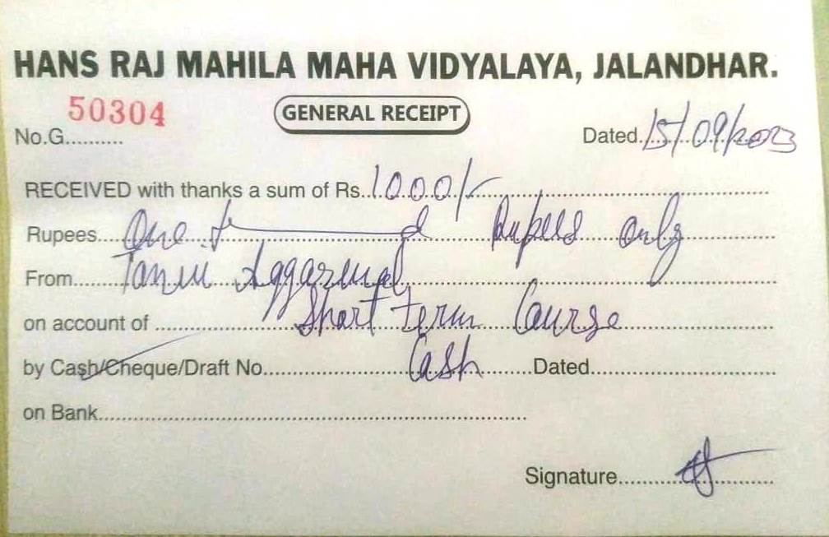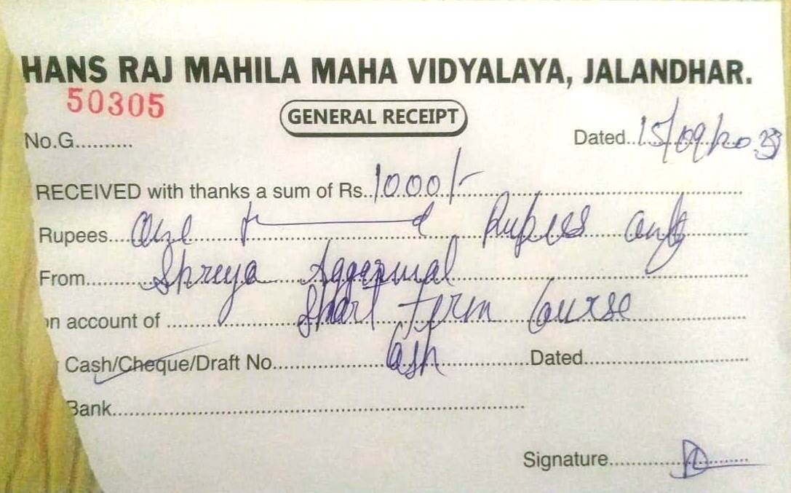

Copy of Student Certificate
